頭條日報
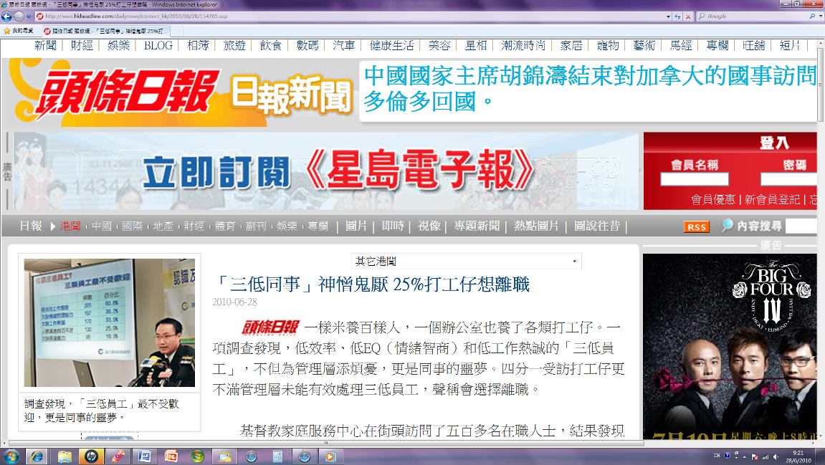

On TV (東方日報)

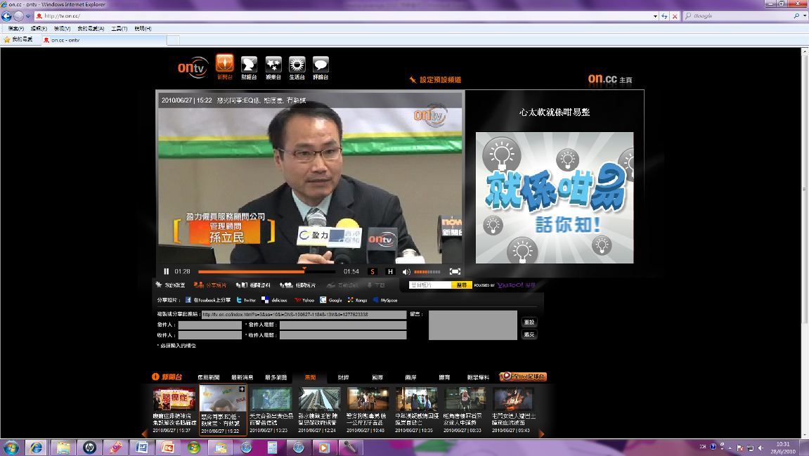
http://tv.on.cc/index.html?s=3&ss=10&i=ONS-100627-11848-13M&d=1277623338

蘋果日報


http://hk.dv.nextmedia.com/template/dv_channel/index.php?fuseaction=dv15.player&mode=section&id=4104&sort=promo&range=d&dv_iss=20100628&iss_id=20100628&sec_id=4104&art_id=14181243&av_id=14181429&page=1

